Contents
Figure S1-S7: Phylogenies 2
Figure S8-S12: Admixture 9
Figure S13-16: Determinants of introgression 14

Figure S1-S7: Phylogenies
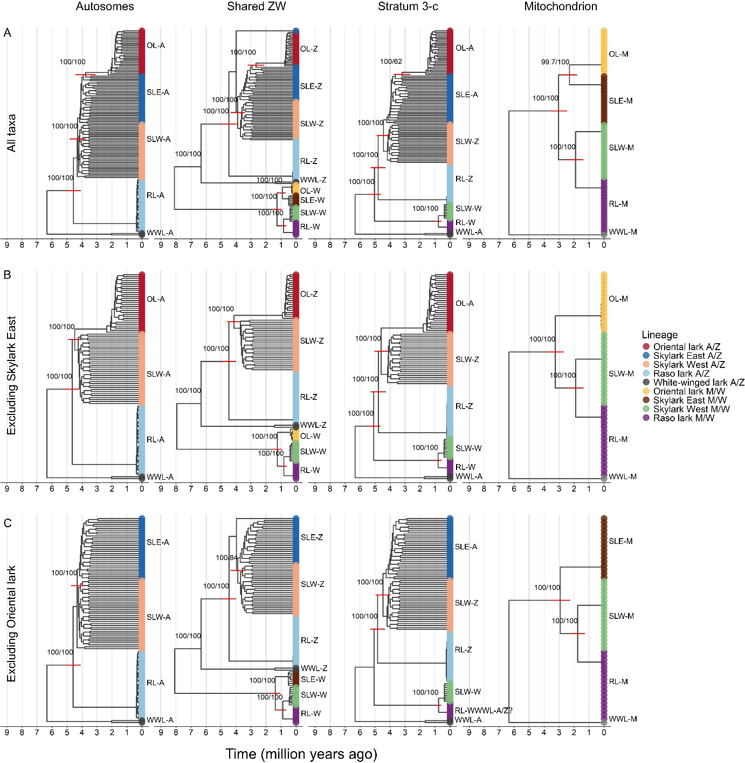
Figure S1. Trees visualising different genomic regions from left to right: autosomes, shared ZW, stratum 3-c, and the mitochondria. Panels visualise trees with (A) all taxa included, (B) eastern skylarks excluded, and (C) oriental larks excluded. A fixed divergence time of 6.3 MY is used for the split of the white winged lark based on Alström et al., (2023). Red bars visualise 95% confidence intervals of lineage splits. Node annotations indicate support values (SH-aLRT branch test / ultrafast bootstrap support). Species names are abbreviated as OL=oriental lark, SLE=skylark east, SLW=skylark west, RL=Raso lark, WWL=white-winged lark. Genomic regions are abbreviated as A=autosomes, Z=Z chromosome, W=W chromosome, M=mitochondrion.
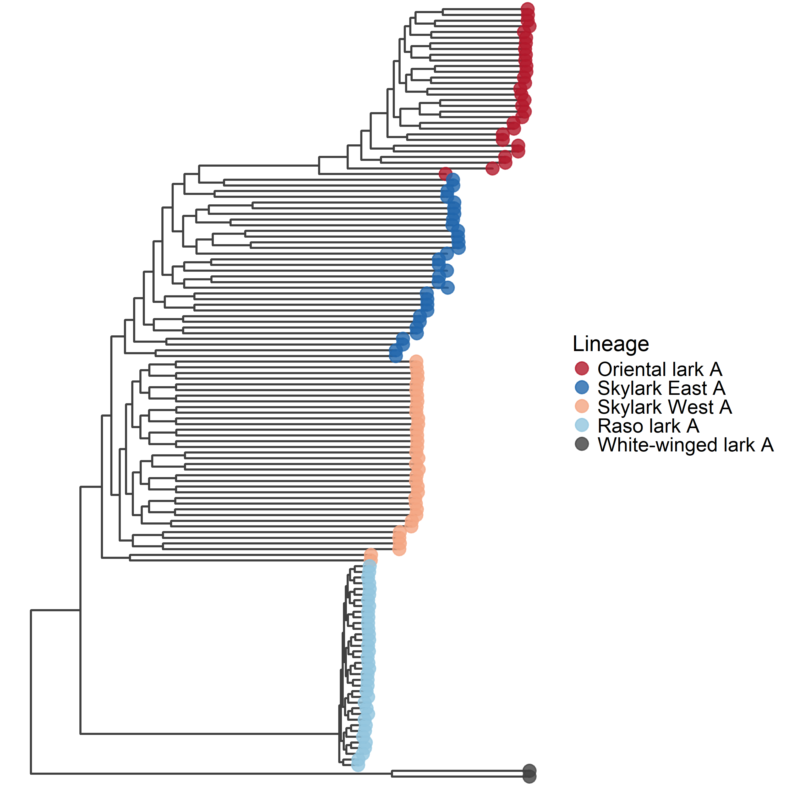
Figure S2. Maximum-likelihood tree based on autosomes using all taxa.
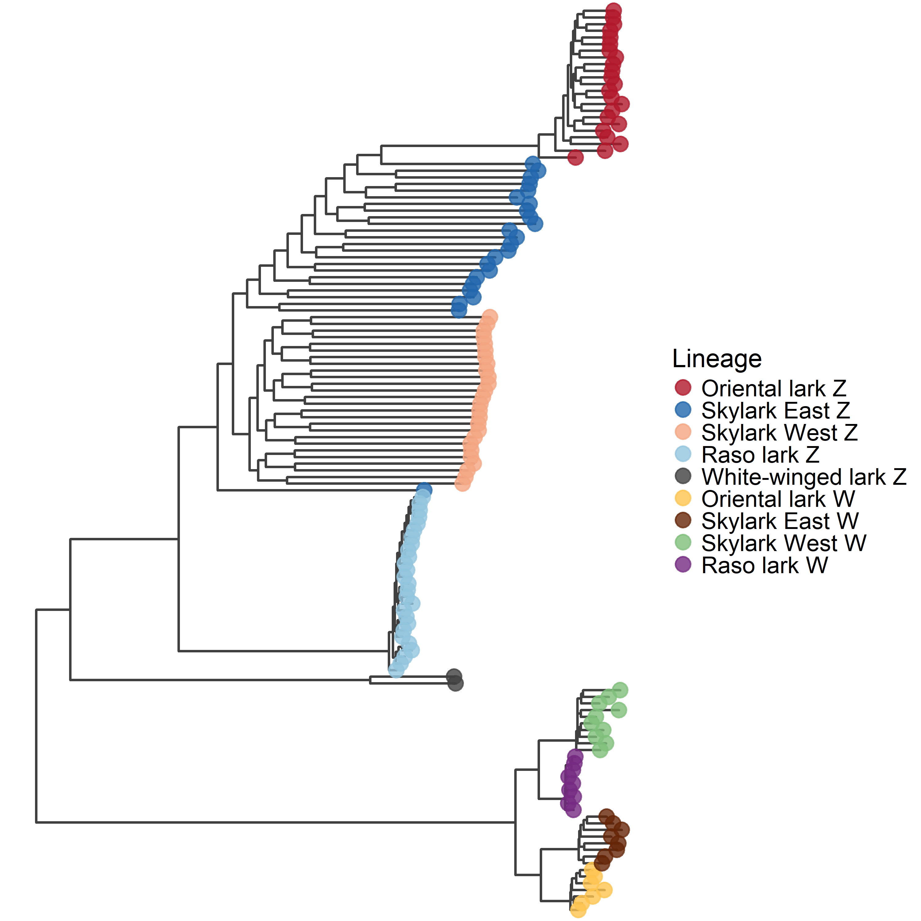
Figure S3. Maximum-likelihood tree based on shared ZW region using all taxa.
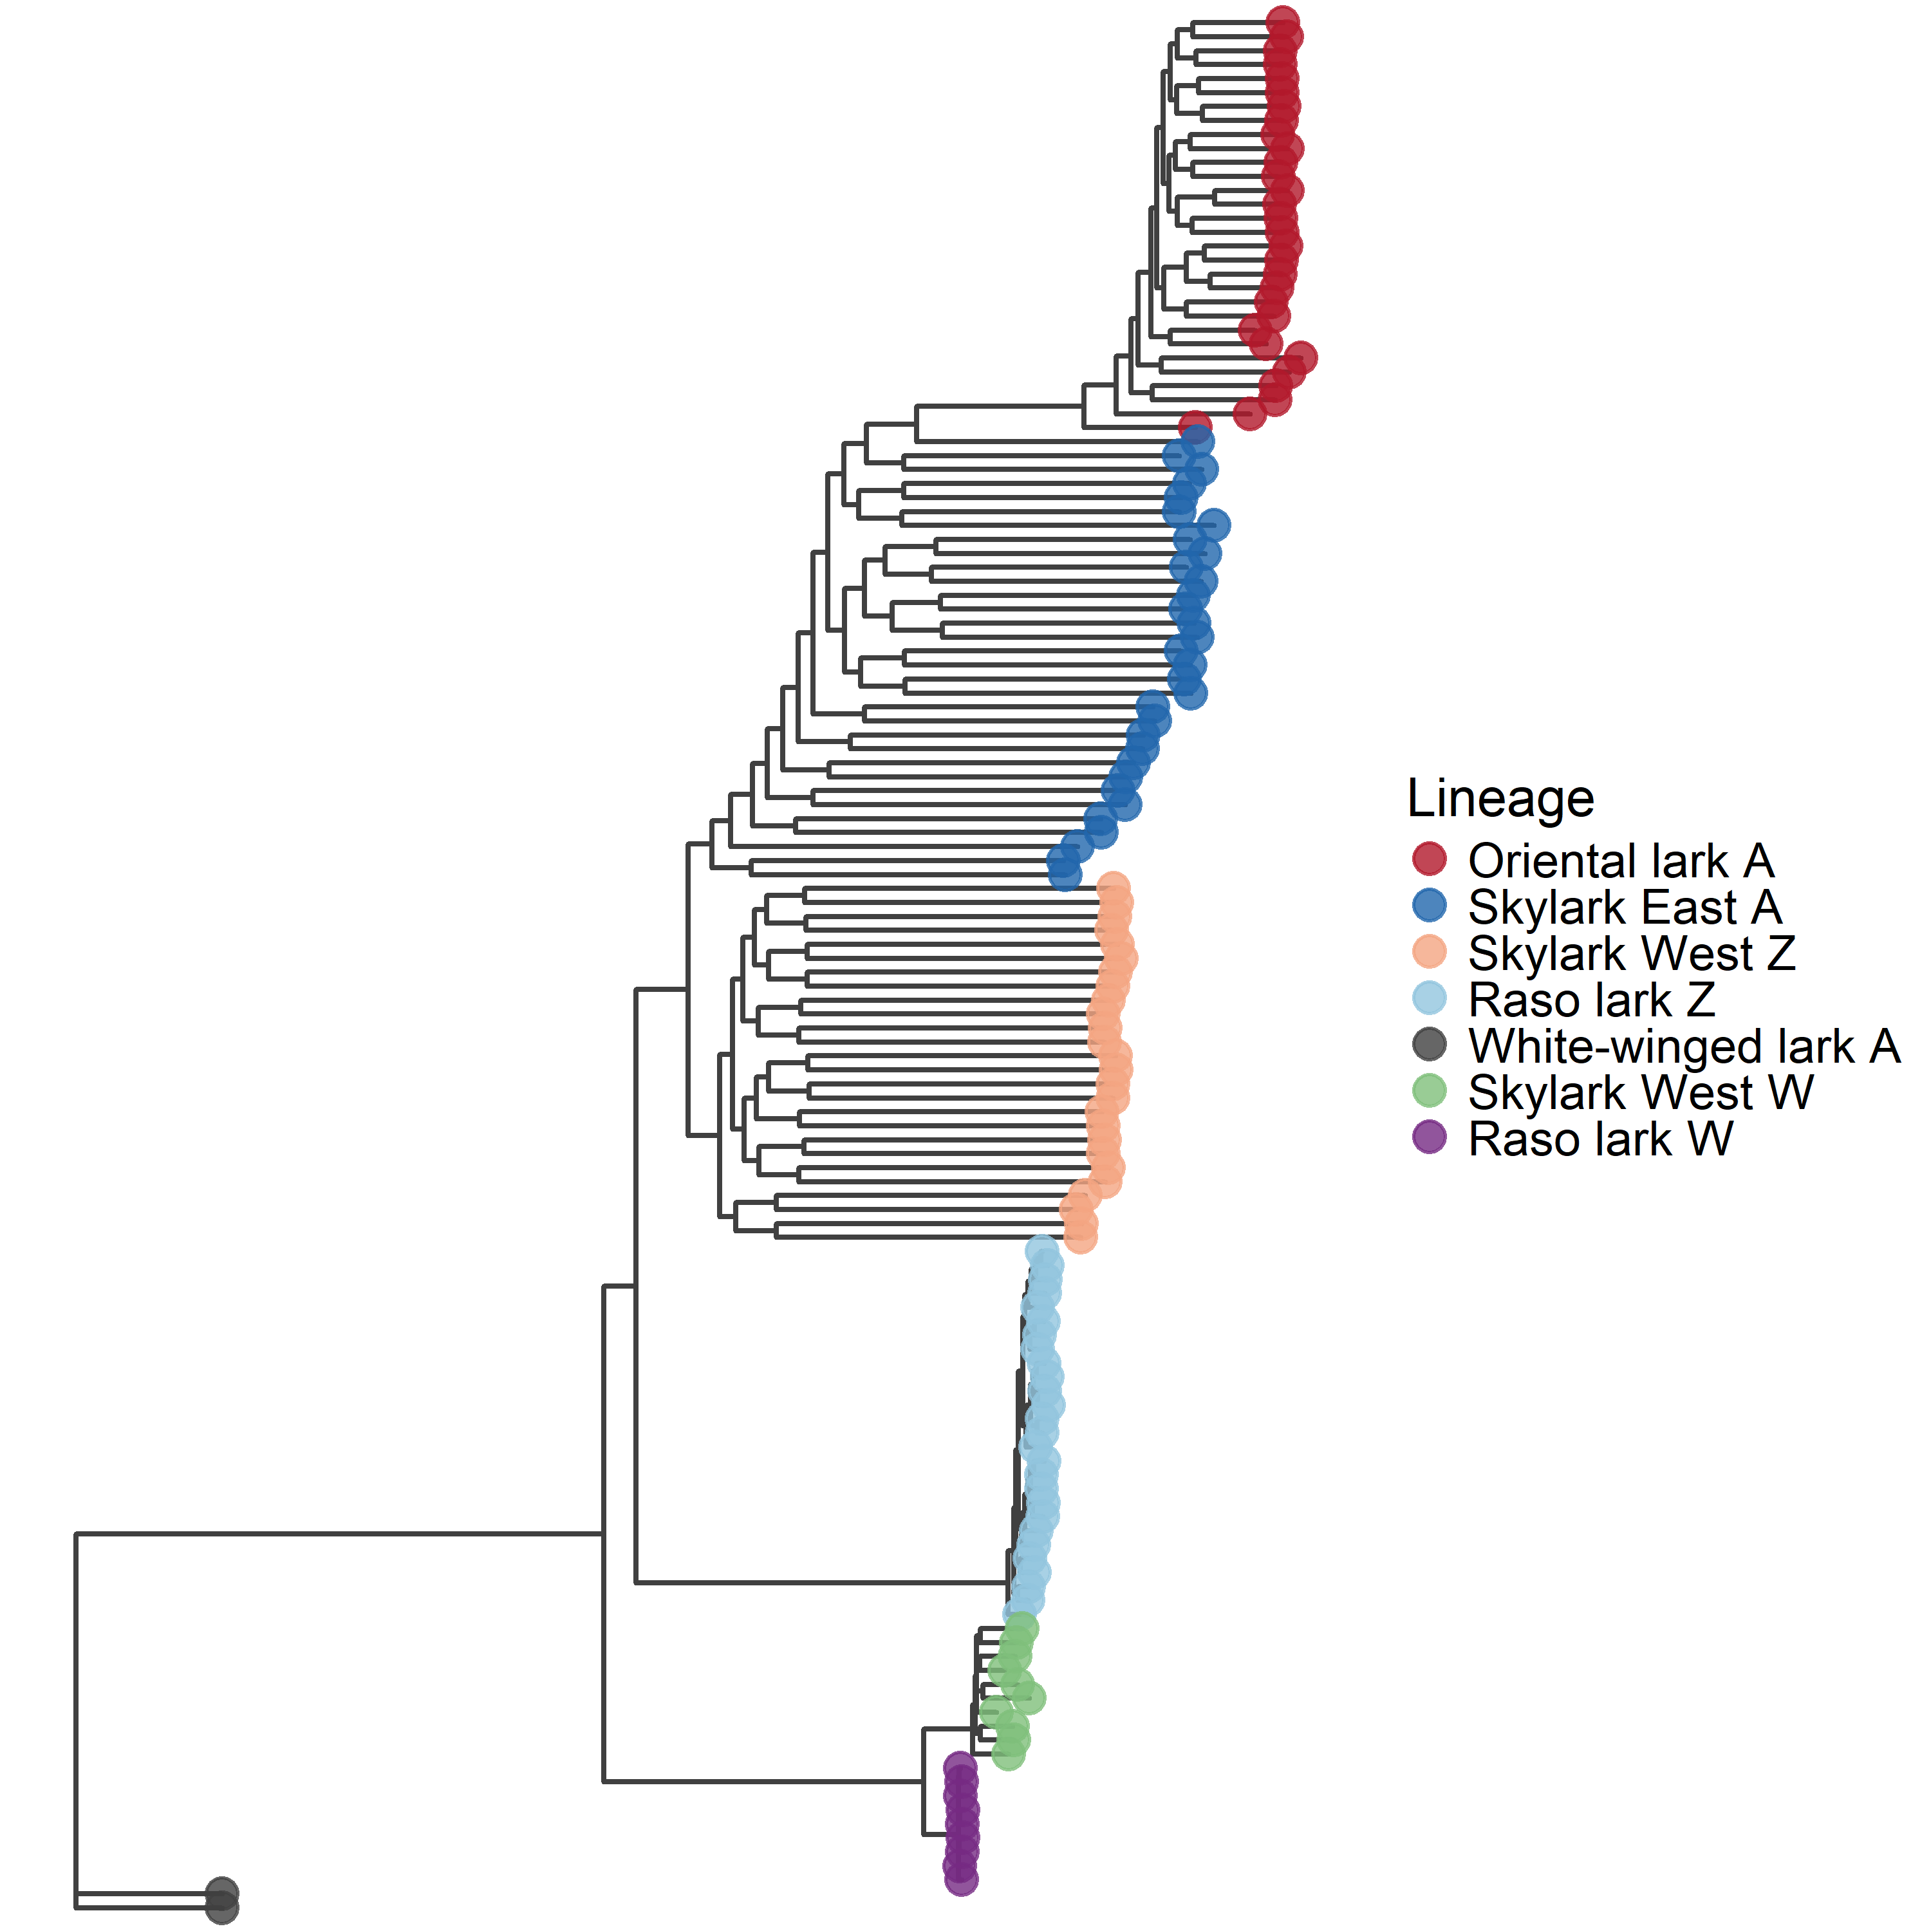
Figure S4. Maximum-likelihood tree based on stratum 3-c using all taxa.
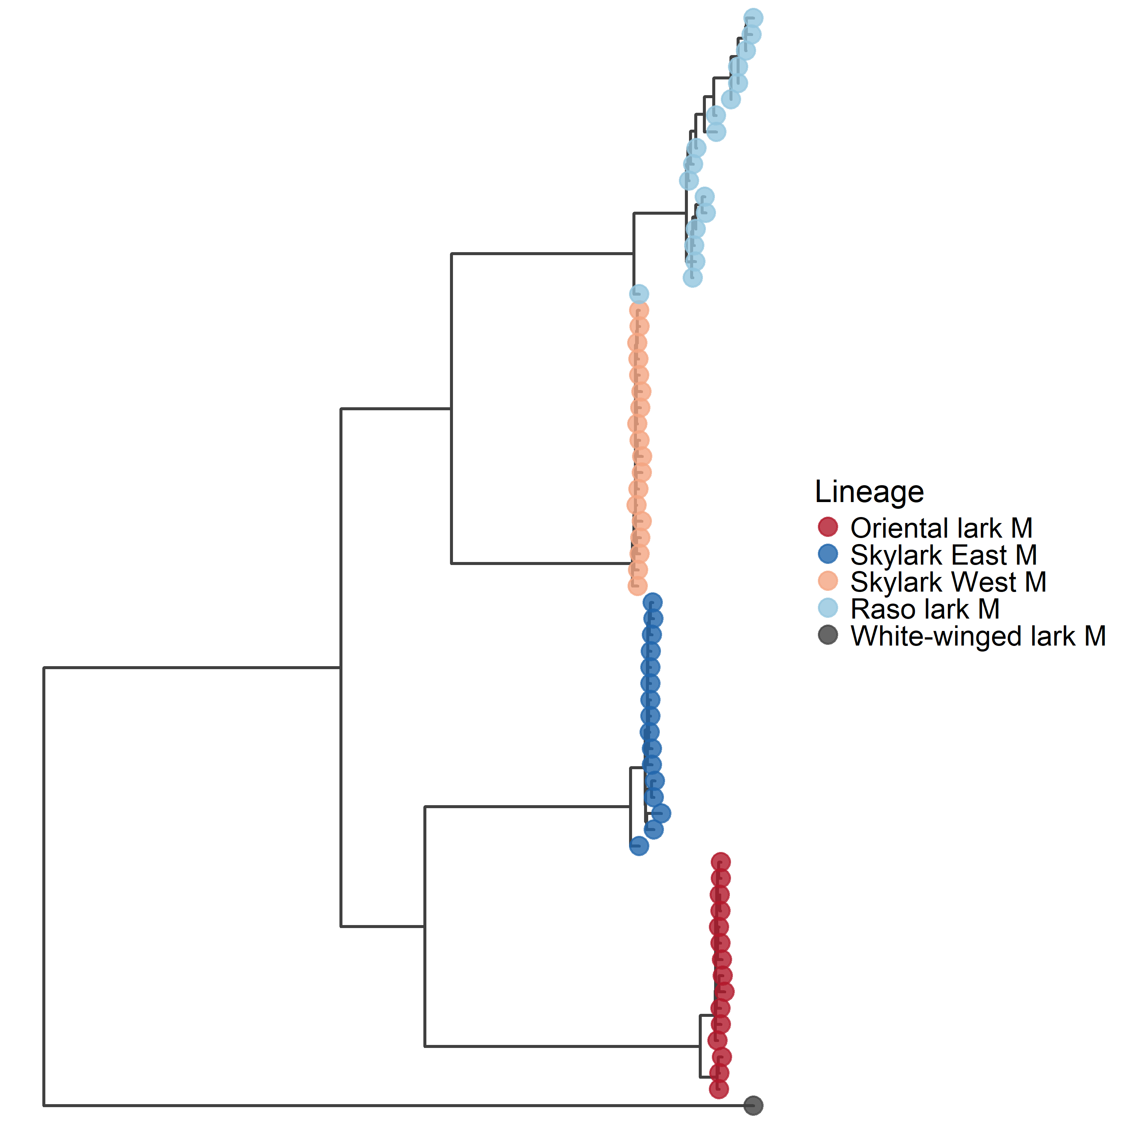

Figure S4. Maximum-likelihood tree based on the mitochondrion using all taxa.
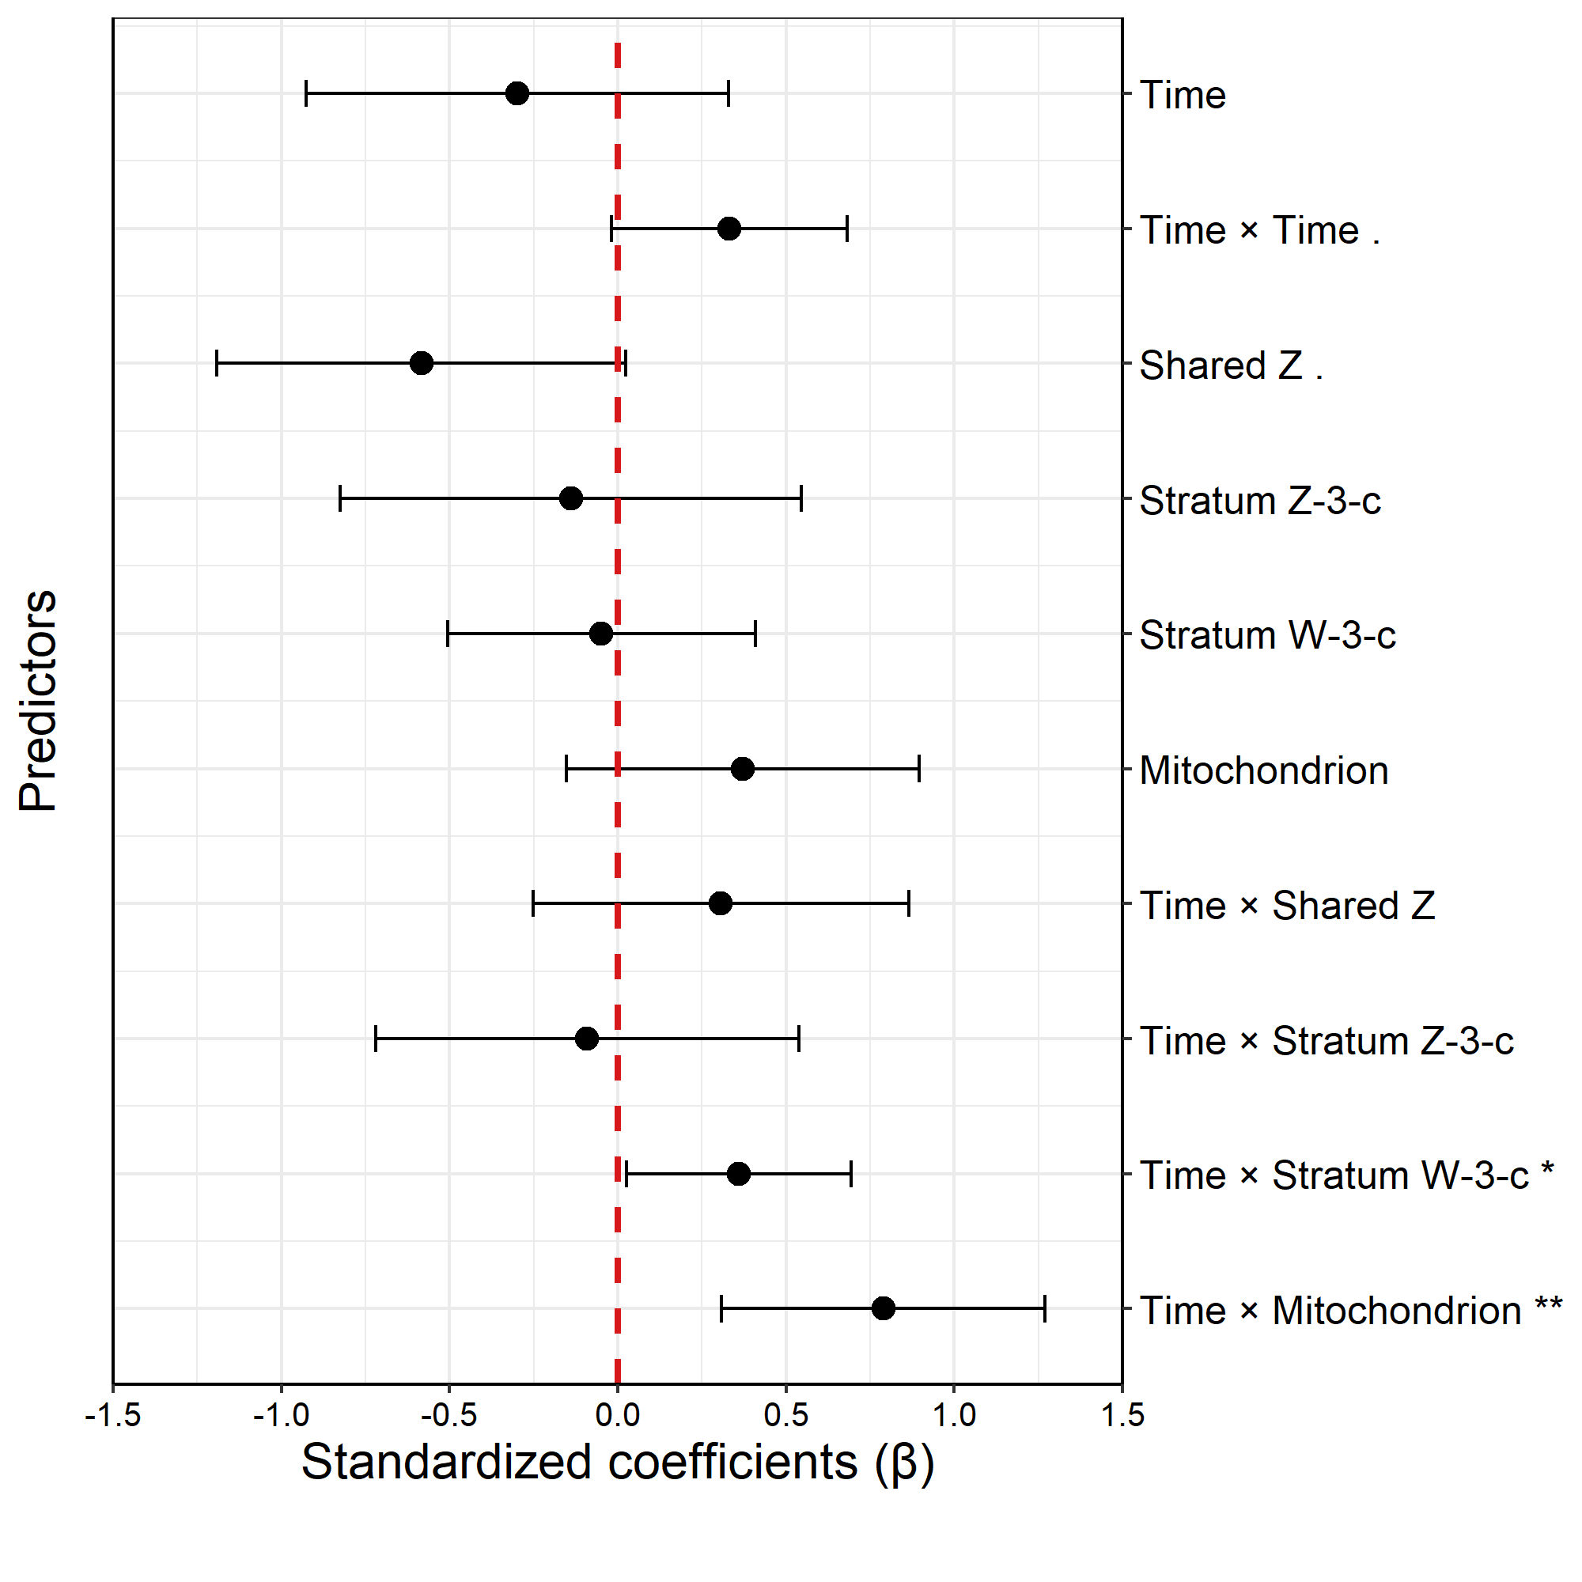 Figure S6. Effect sizes (β) from GLM testing evolutionary rate changes over time in autosomes, shared Z, autosomes/stratum Z-3-c, stratum W-3-c, and the mitochondrion.
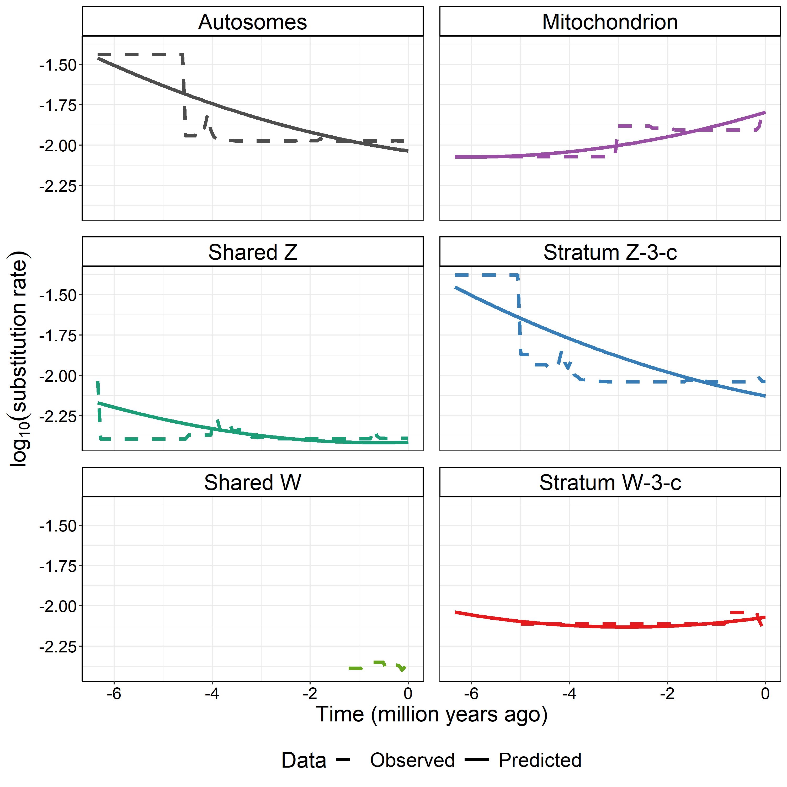
Figure S7. Substitution rates in nuclear regions based on putatively neutral intergenic SNPs (located at least 20 kb from exons) generally decrease throughout evolutionary time in the genus Alauda. In the mitochondrion, which is based on all SNPs, substitution rates instead increase over time. When phylogenetic dating is based on time calibrations, a relative increase in substitution rates towards the present is expected to result in older species divergence estimates, as more substitutions result in increased branch lengths.

Figure S8-S12: Admixture
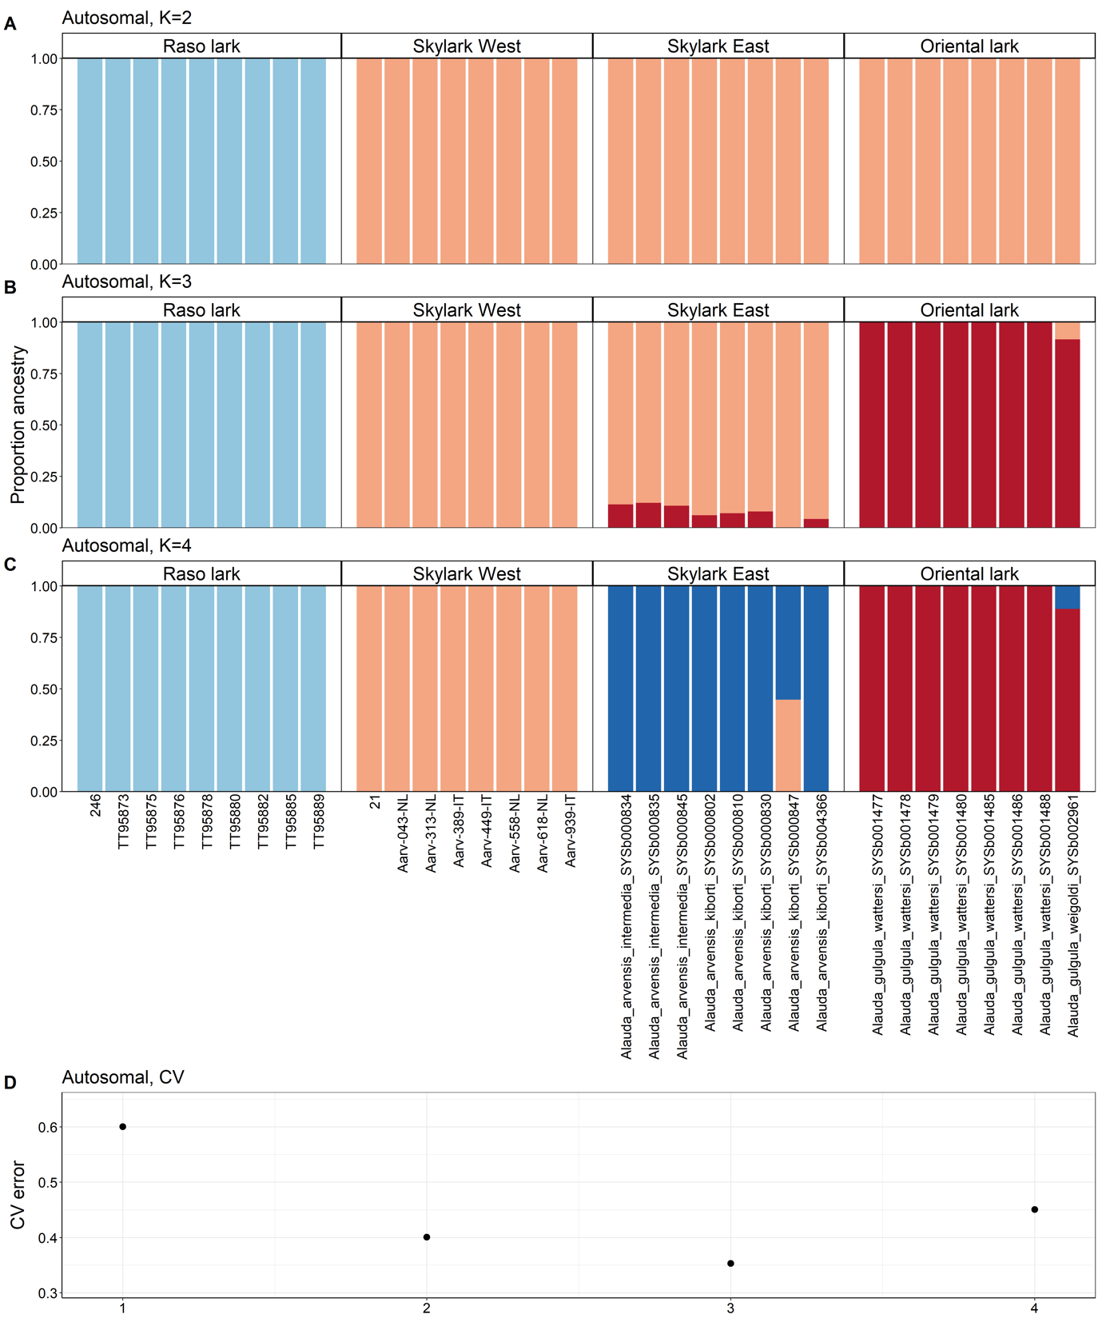
Figure S8. The proportion of ancestry in autosomes with lineages assigned to clusters (A) K=2, (B) K=3, and (C) K=4. (D) CV error when lineages assigned to clusters K=1-4.
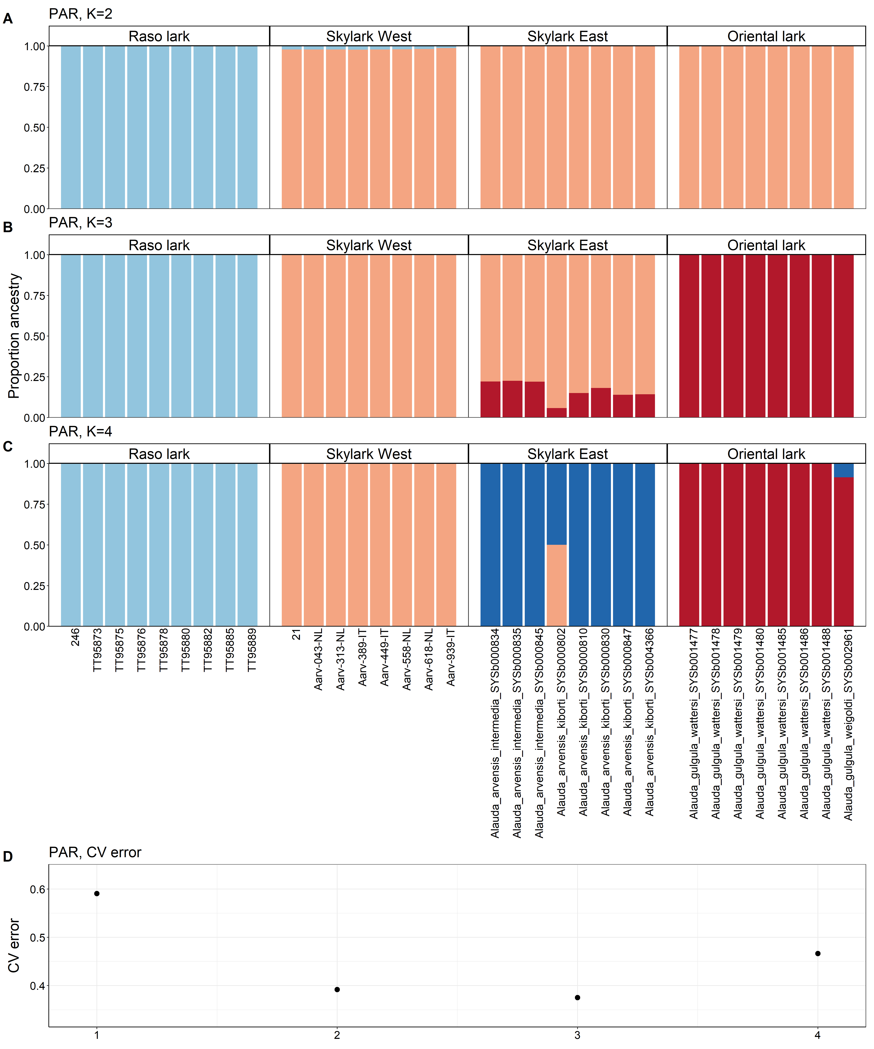
Figure S9. The proportion of ancestry in PARs with lineages assigned to clusters (A) K=2, (B) K=3, and (C) K=4. (D) CV error when lineages assigned to clusters K=1-4.
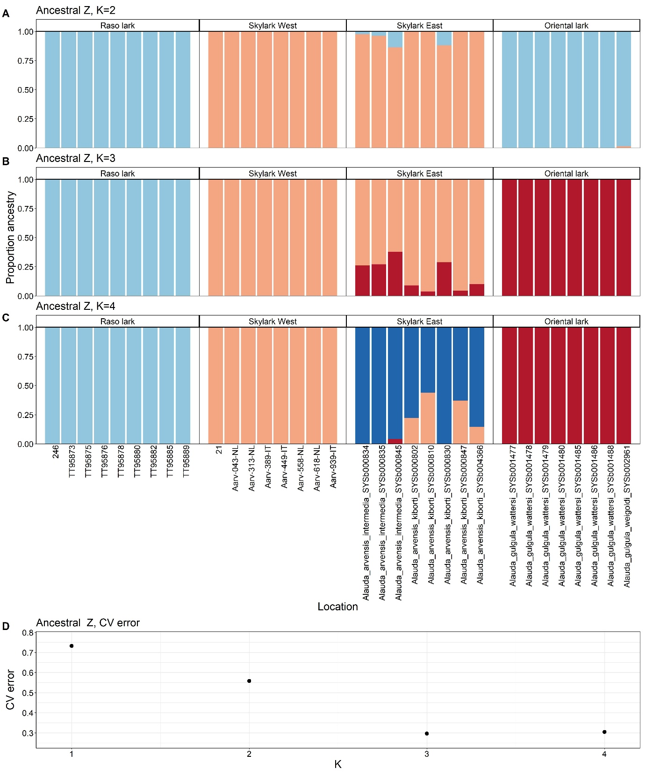
Figure S10. The proportion of ancestry in Ancestral Z with lineages assigned to clusters (A) K=2, (B) K=3, and (C) K=4. (D) CV error when lineages assigned to clusters K=1-4.
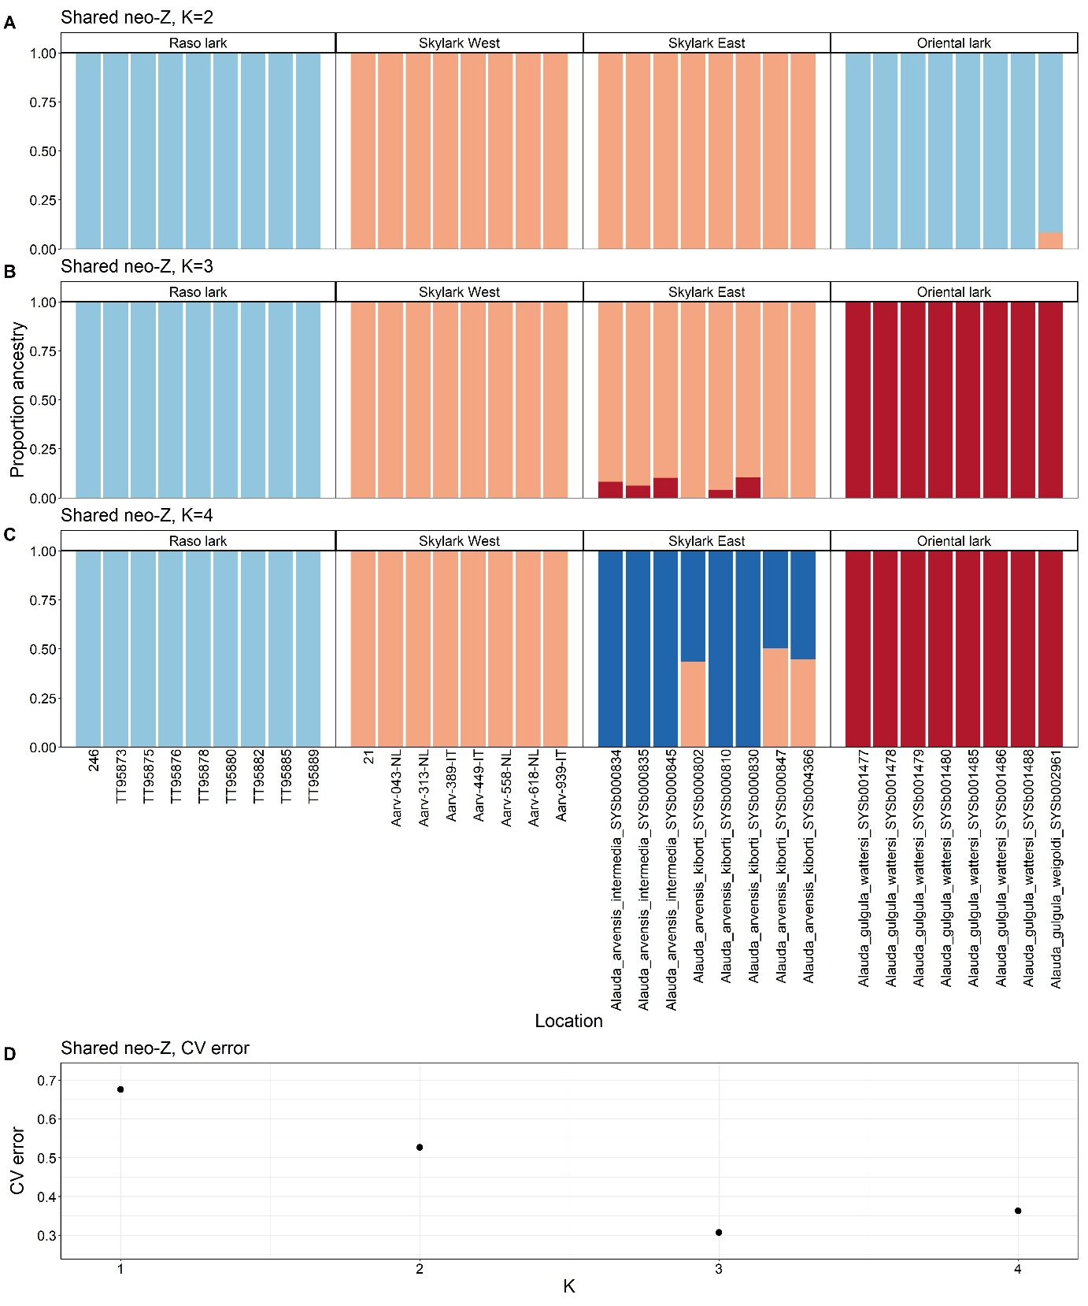
Figure S11. The proportion of ancestry in shared neo-Z with lineages assigned to clusters (A) K=2, (B) K=3, and (C) K=4. (D) CV error when lineages assigned to clusters K=1-4.
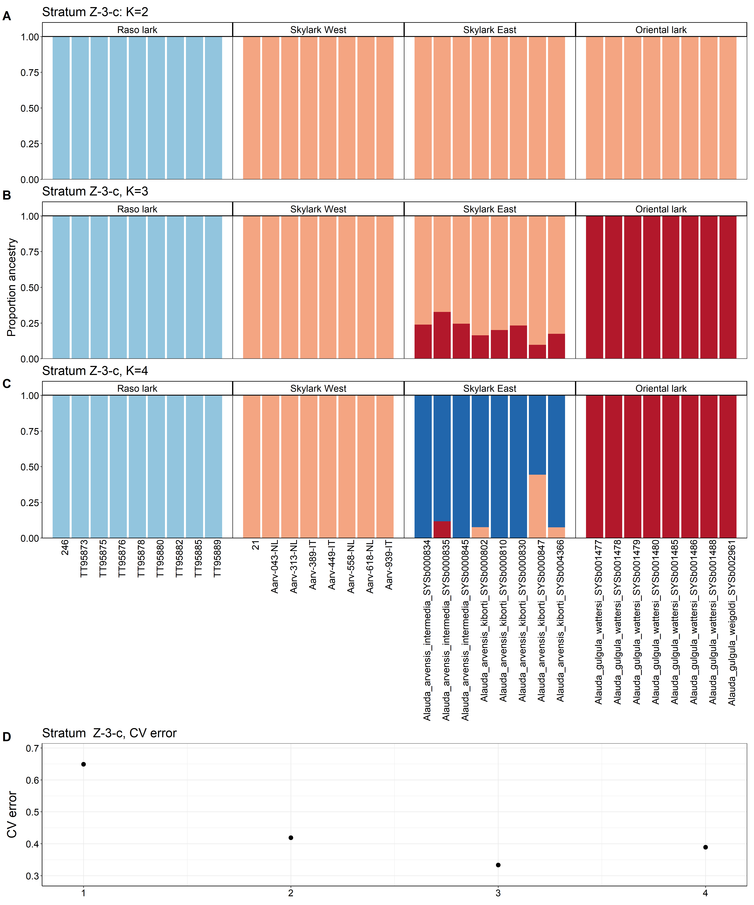
Figure S12. The proportion of ancestry in stratum Z-3-c with lineages assigned to clusters (A) K=2, (B) K=3, and (C) K=4. (D) CV error when lineages assigned to clusters K=1-4.

Figure S13-16: Determinants of introgression
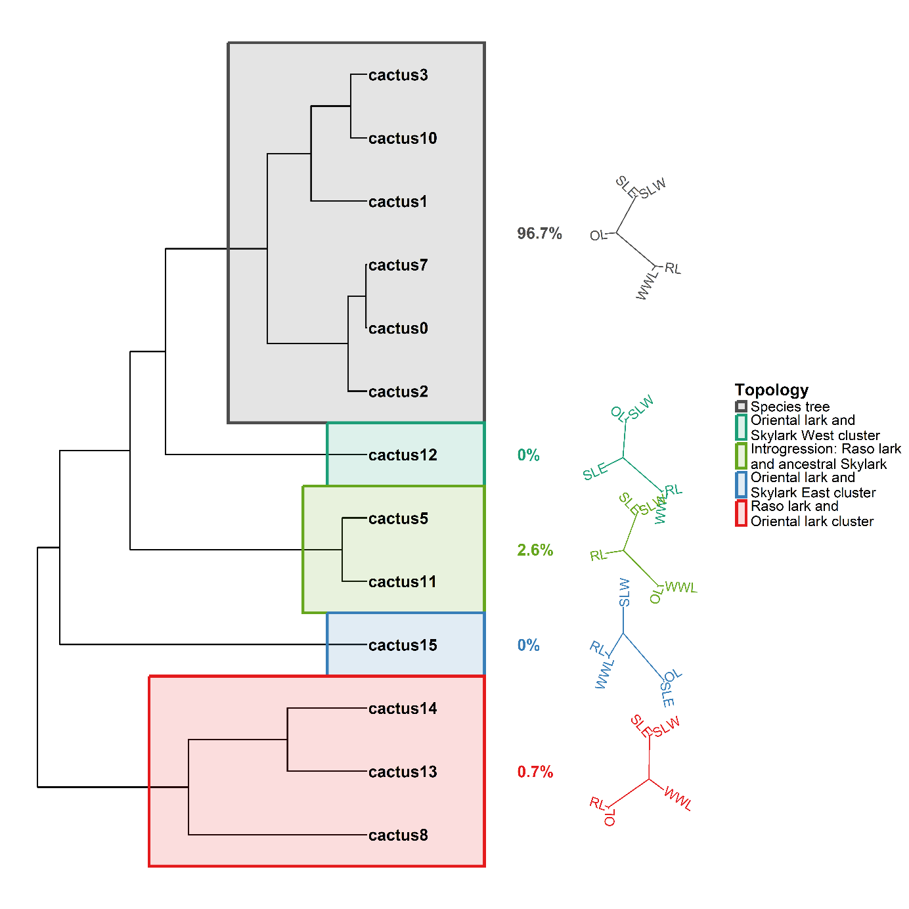
Figure S13. Cacti (topologies) inferred across the genome, clustered by similarity using hierarchical clustering and manual inspection. Percentages correspond to the proportion of the analysed genome covered by respective cluster of cacti. The topologies represent a weighted mean topology, weighted by the proportion of the genome covered by each cactus within a cluster. The legend showcases an interpretation of respective cluster of cacti. Species names are abbreviated as OL=oriental lark, SLE=skylark east, SLW=skylark west, RL=Raso lark, WWL=white-winged lark.

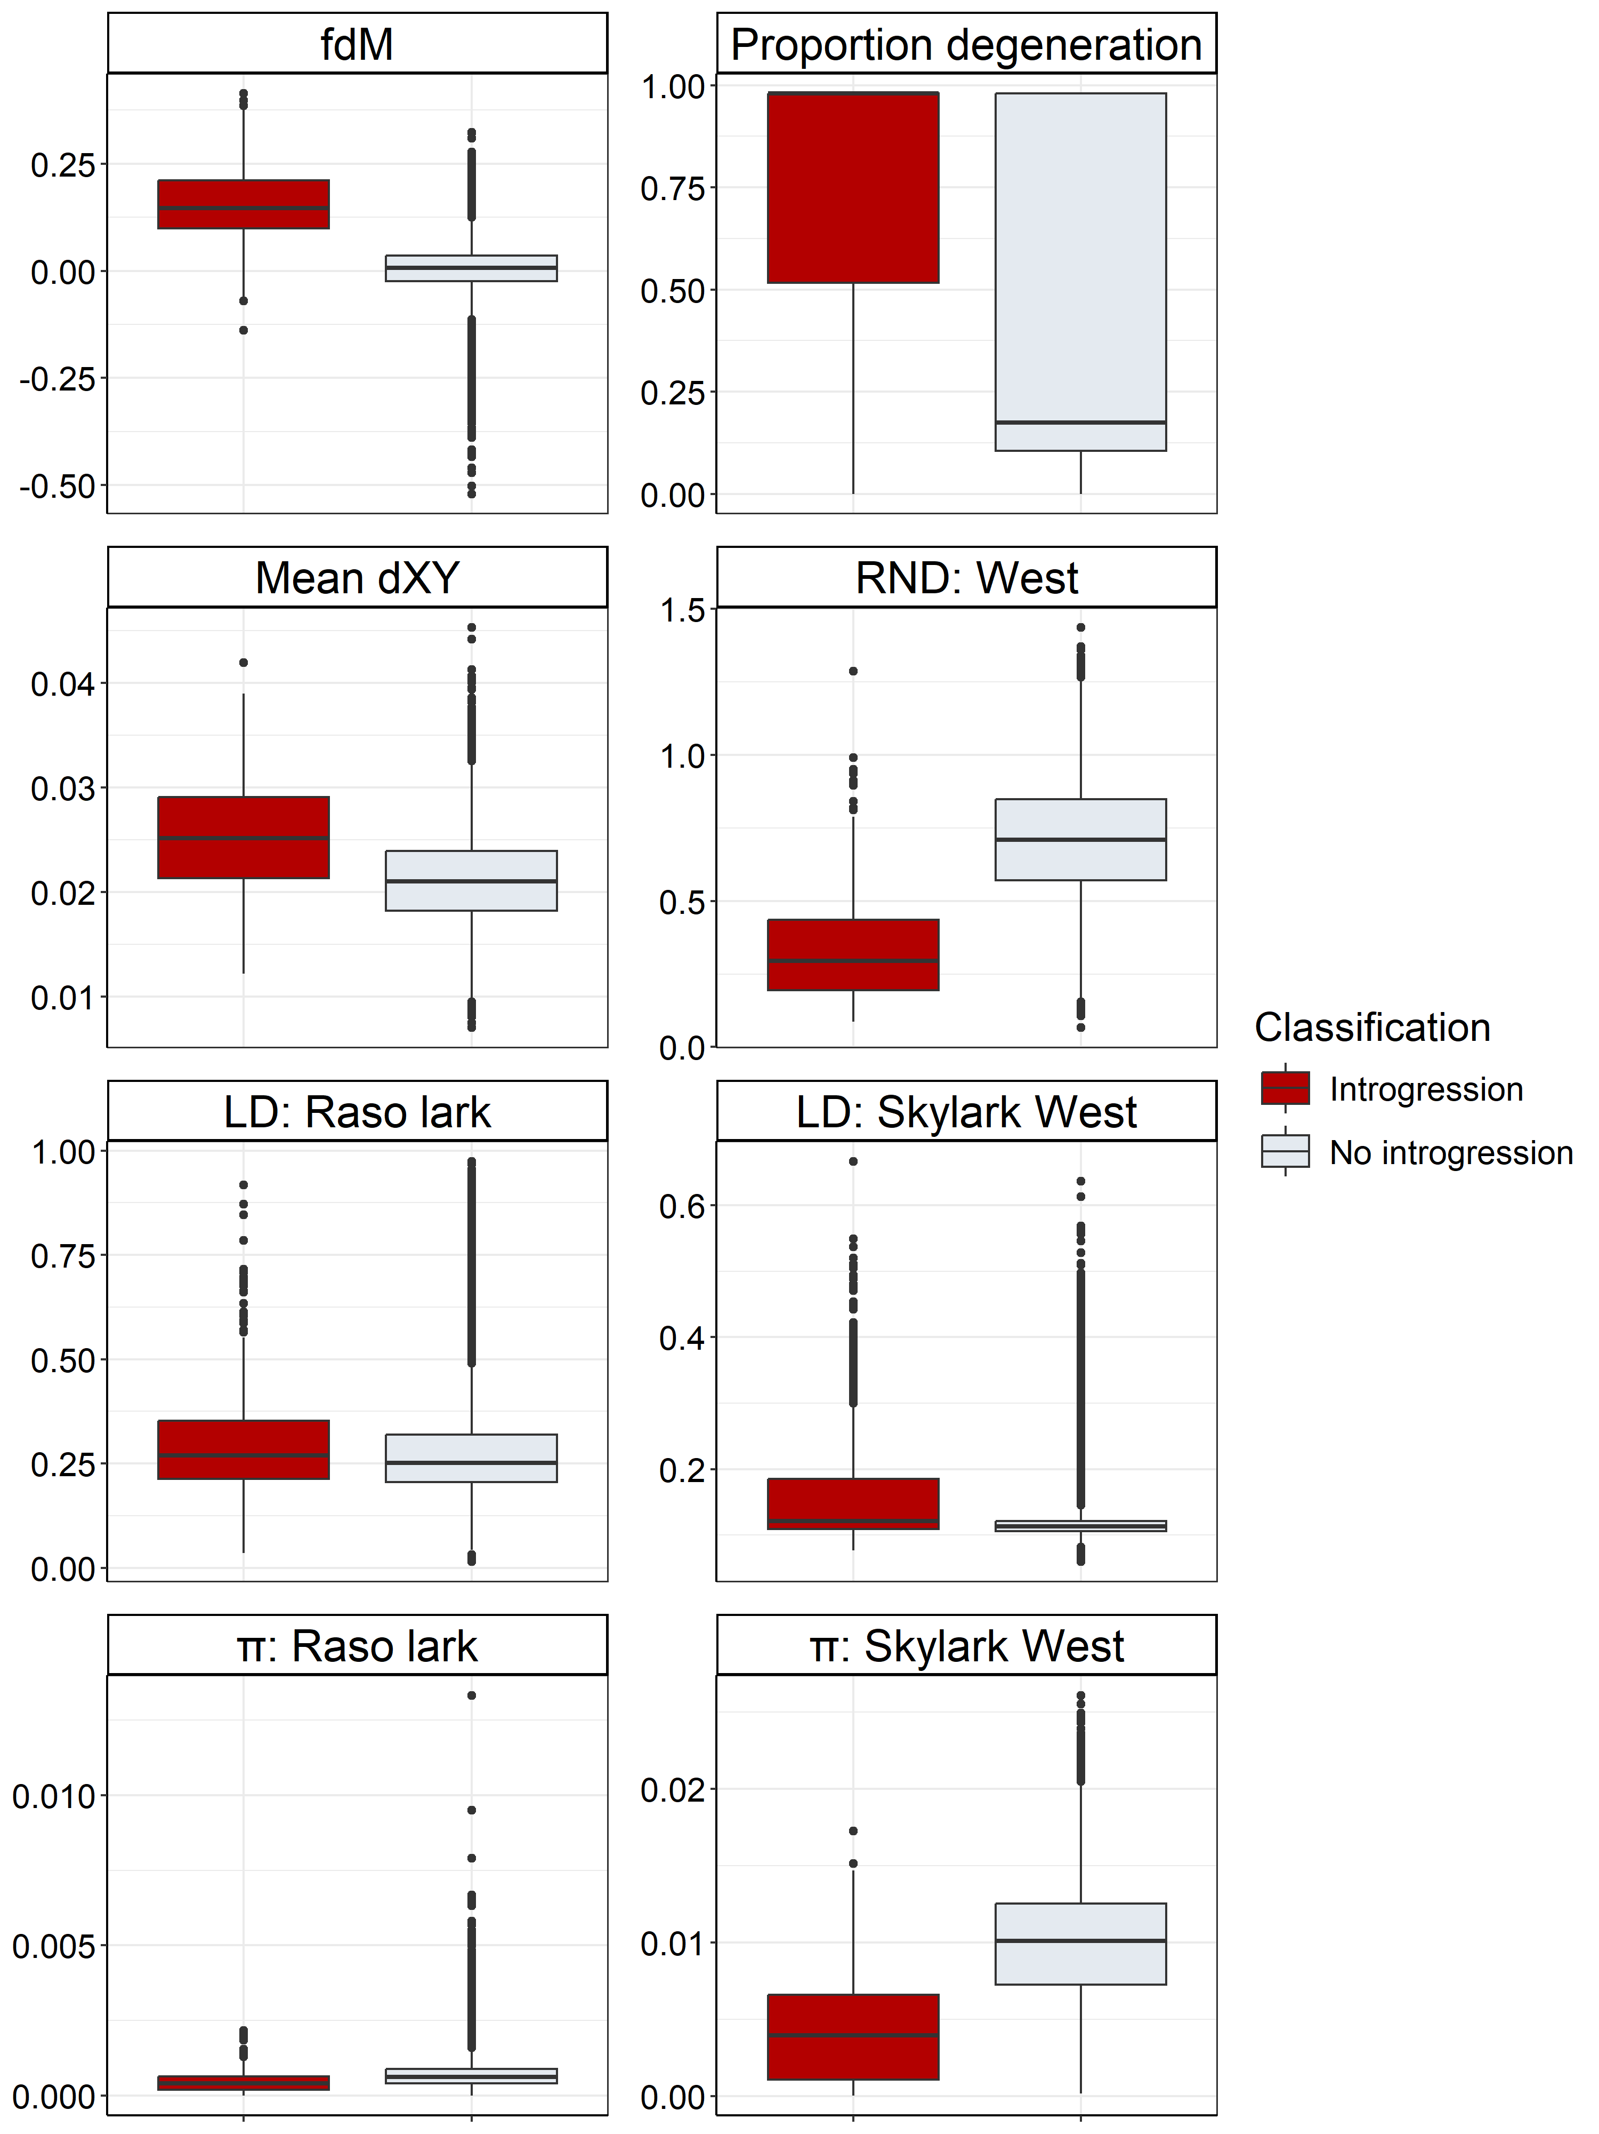
Figure S14. Distribution of population genomic metrics in windows classified as involved in introgression or not. Abbreviations: π: nucleotide diversity, d_{XY}: absolute divergence, RND=relative node depth, LD=linkage disequilibrium, RL=Raso lark, SLW=skylark west.
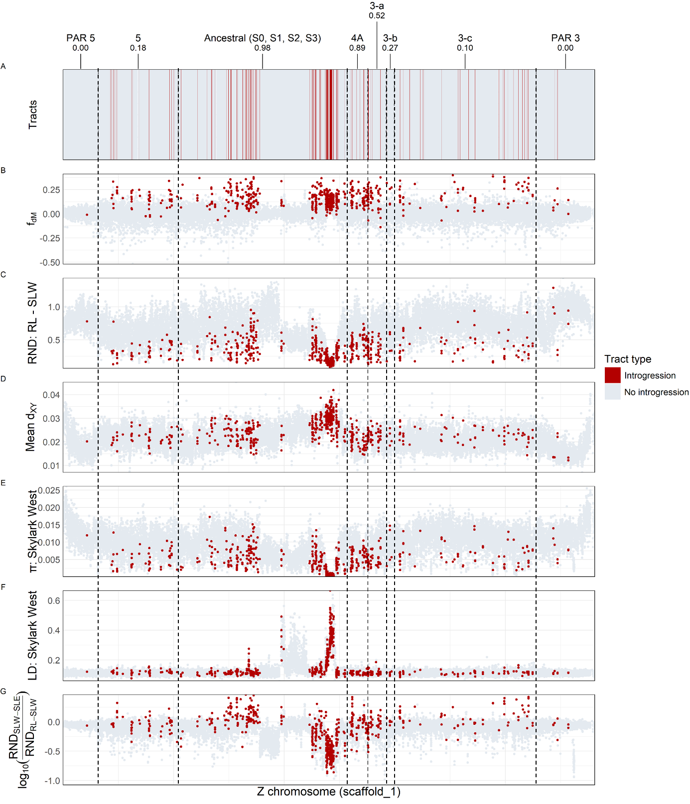
Figure S15. Population genomic metrics visualised across the Z chromosome: (A) Tracts of introgression, (B) the f_{dM} (proportion of introgression), with higher values indicating more introgression between the Raso lark and western skylark, (C) relative node depth (RND) between Raso lark and western skylark, with lower values indicating recent divergence, (D) mean absolute divergence (d_{XY}) from the white-winged lark to respective species, indicating heterogeneity in divergence rate, (E) nucleotide diversity (π) in western skylarks, (F) linkage disequilibrium (LD) in western skylarks, indicating tightly linked genomic regions, and (G) our local adaptation metric (LA), with high values indicating reduced divergence between the Raso lark and western skylarks compared to between western and eastern skylarks. Strata are annotated by name and the proportion of W loss-of-function gametologs.
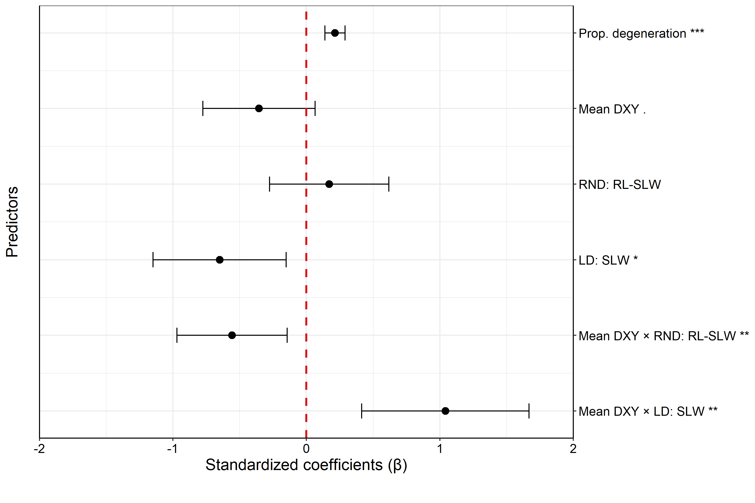
Figure S16. Effect sizes (β) from GLM testing introgressed tract lengths on the Z chromosome in relation to predictors. Abbreviations: RND=relative node depth, LD=linkage disequilibrium, OL=oriental lark, SLW=skylark west.

